**Unveiling Novel Approaches: Machine Learning Optimization for Circularly Polarized Antennas Tailored for 5G Communication**

Manav Kakkar

B.E CSE with specialization in AIML

Chandigarh University

Mohali, Punjab

21BCS6294

***Abstract*—**

This paper advocates the application of Machine Learning techniques in the domain of antenna design and optimization to expedite the entire process. The conventional approach to antenna design has been notably time-consuming due to the intricate and computationally intensive numerical methods involved. The utilization of simulation software, such as HFSS, adds to the complexity, providing parameter results based on predefined dimensions or dimension ranges, but at the expense of significant time investment. Consequently, there is a compelling need for optimization to align the antenna's characteristics with the desired parameters efficiently.

In this study, we propose the creation of a circularly polarized dielectric resonator antenna specifically designed for 5G communication and tuned to operate at a resonant frequency below 6 GHz. To enhance the efficiency of the design process, we leverage the capabilities of five distinct machine learning algorithms, namely bagging ,boosting, KNN, and ANN. Remarkably, the KNN algorithm, particularly with k=9, demonstrates notable success, achieving an impressive accuracy rate of up to 98.7%.The results obtained through this approach enable the estimation of dimensions for desired parameters, a task previously challenging with HFSS alone. This signifies a significant advancement in antenna design efficiency facilitated by Machine Learning methodologies.

**Keywords** Prediction Model,Classification and Regression,Heuristic value,Decision Stump,Bagging

1. Introduction

In recent years, the widespread availability of affordable data storage and processing capabilities has propelled the integration of machine learning into diverse fields. Machine learning now offers a streamlined approach to identifying optimized solutions across various domains.[1] With a surge in demand for high-speed and dependable communication networks, particularly in anticipation of 5G applications, there is an imperative need for smart and efficient methods in antenna design.[2]

Traditional antenna design focused on determining optimal geometries to meet performance criteria within specified frequency ranges. [3]This iterative design and analysis process, often relying on High-Frequency Simulation Software (HFSS) to create prototypes and simulate optimal geometries, involves repeated trials until the desired configuration is achieved. [4]

However, the conventional optimization process, characterized by trial and error, is time-consuming.

This paper proposes leveraging machine learning techniques for antenna design optimization to expedite the process.

Meenakshi Yadav

B.E CSE with specialization in AIML

Chandighar University

Mohali, Punjab

21BCS6048

[5]Machine learning algorithms are expected to predict antenna dimensions based on parameters like resonant frequency and reflection coefficient, offering an alternative to the iterative trial and error loop.[6] The chosen algorithms, including decision tree, random forest regression, gradient boosting regression, KNN, and ANN, are capable of handling non-linear regression, aligning with the dataset obtained from simulations.[7]

The research involves obtaining a dataset through antenna simulations using HFSS, with varied dimensions and resonant frequencies ranging from 2 to 6 GHz. The ML algorithms are then employed to make predictions, and the MSE value is used to quantify prediction accuracy by comparing simulated and predicted antenna parameters.[10] This approach holds the promise of significantly enhancing the efficiency of antenna design optimization through the application of machine learning methodologies.[11]

In the landscape of modern technology, where communication networks are evolving rapidly, the advent of 5G applications has intensified the need for innovative approaches to antenna design. [12]The traditional iterative process of achieving optimal antenna configurations through trial and error has proven time-consuming, prompting a shift toward the integration of machine learning techniques.[13]

Machine learning provides a novel avenue for accelerating the antenna design optimization process. By harnessing algorithms such as bagging, boosting regression, KNN, and ANN, the goal is to predict antenna dimensions directly from crucial parameters like resonant frequency and reflection coefficient. This departure from conventional methods aims to break free from the repetitive cycle of adjustments and simulations, potentially saving significant time and resources.[14]

The research methodology involves conducting antenna simulations using HFSS, exploring various dimensions with resonant frequencies spanning 2 to 6 GHz. [15]The resulting dataset, comprising resonance frequency, reflection coefficient, height of the upper dielectric resonator, and length to the ground, serves as the foundation for the machine learning algorithms. These algorithms are chosen for their ability to handle non-linear regression, aligning with the intricacies of the dataset derived from simulations.[16]

Prediction accuracy is quantified through the MSE value, providing a comprehensive evaluation of the machine learning models' efficacy in anticipating antenna parameters. This innovative approach not only promises efficiency gains but also represents a paradigm shift in the way antenna design and optimization are approached in the context of emerging communication technologies. The fusion of machine learning and antenna design holds the potential to revolutionize the field, paving the way for faster, more accurate, and resource-efficient solutions.

1. LITERATURE REVIEW

Hamdi Bilel etal. 2022 The review of the paper titled "Radiation Pattern Synthesis of the Coupled almost Periodic Antenna Arrays Using an Artificial Neural Network Model”. This paper underscores the efficacy of multilayer feedforward neural networks in addressing the complexities associated with almost periodic antenna patterns. Emphasizing the advantages of utilizing ANN, the study highlights the application of the early stopping (ES) method for generalization, leading to enhanced speed and reduced memory consumption.

Furthermore, the paper offers practical examples to substantiate its approach, demonstrating the effectiveness of the proposed methodology. It explores the complexities of establishing the most suitable dimensions for a feedforward neural network, aiming to address concerns related to overfitting. Additionally, it provides insights into the reasoning behind the segmentation of radiation model datasets into distinct sets for training, testing, and validation purposes.

Ayush Srivastava et al., 2022, "Aperture Coupled Dielectric Resonator Antenna Optimization using Machine Learning Techniques":The study by Ayush Srivastava and colleagues delves into the optimization of Aperture Coupled Dielectric Resonator Antennas (DRAs) through the utilization of Machine Learning (ML) techniques. While the provided sources do not explicitly present a dedicated literature review section, they contribute to the existing knowledge on the subject.[8]The research aligns with the broader trend observed in recent literature, emphasizing the integration of machine learning algorithms for antenna optimization. A significant focus is given to comparing the performance of these algorithms with the outcomes obtained from the HFSS and EM simulator.[9]

1. Methodologies
2. *Antenna Design and Configuration*

A novel stair-shaped circularly polarized dielectric resonator antenna (CPDRA) has been meticulously designed using Ansys HFSS, operating within the sub-6 GHz frequency band spanning from 2 to 6 GHz [6]. The antenna configuration involves two dielectric resonators strategically positioned in a stair-shaped arrangement above one another. These resonators are symmetrically placed concerning the microstrip feed, as depicted in Fig. 1

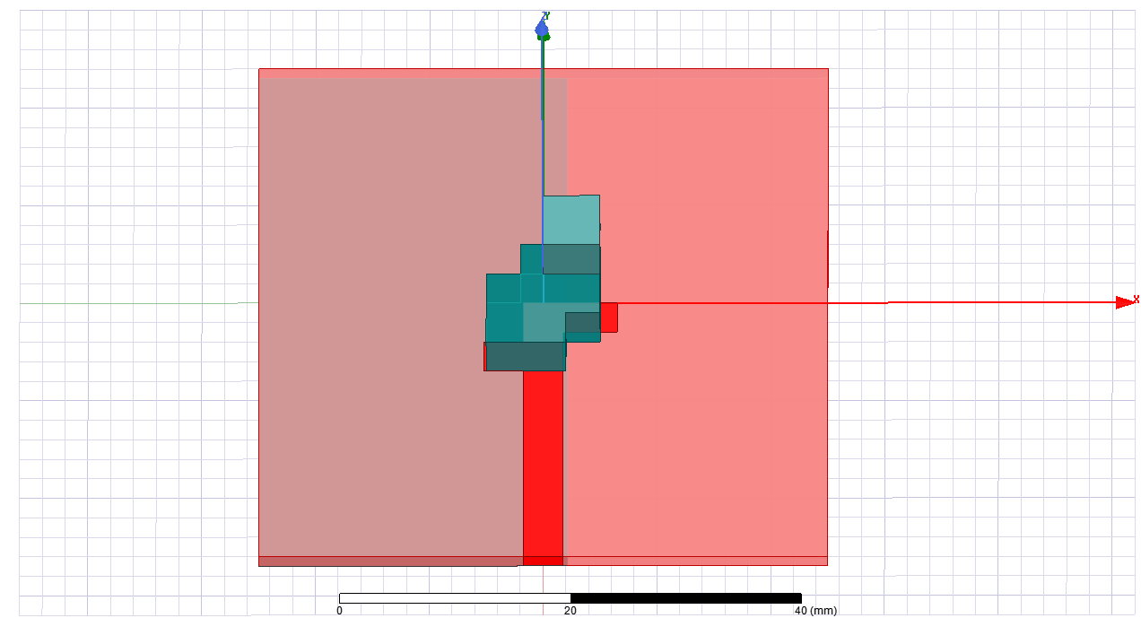

Fig. 1. Antenna Top View

The fabrication process for the antenna involves using an FR4 substrate with specific dimensions and properties. The substrate, having a thickness of 1.6 mm and a relative permittivity of 4.4, is characterized by dimensions measuring 50 mm in both length and width. It's worth noting that the ground structure on the substrate has a width of 50 mm, but its length is limited to 27.1 mm, as depicted in Fig. 2.

The proposed Dielectric Resonator Antenna (DRA) features a feed line with a width of 3.5 mm and a length of 26 mm. This feed line incorporates two stubs: one with a length of 5 mm and a width of 3 mm, and another with a length of 3.5 mm and a width of 3 mm. The connection from this feed line extends to a port positioned on the side of the substrate. The dimensions of this port are specified with a length of 1.6 mm and a width of 3.5 mm, and it is excited with an impedance of 50 ohms. This detailed configuration is outlined in the illustration provided.



Fig. 2. Antenna Rear View

A dielectric resonator is positioned over the feed line, featuring two cuts from opposing sides. The dielectric resonator has dimensions, with a length and width of 10 mm and a height of 5 mm. Another dielectric resonator is then placed atop the initial one, with dimensions of 5 mm in length, 5 mm in width, and a height that is not specified.

This constructed Dielectric Resonator Antenna (DRA) has undergone both fabrication and testing, generating responses within the sub-6 GHz range.

1. *Dataset preparation*

In this study, electromagnetic wave simulations of the antenna are conducted using the HFSS simulation software, generating a dataset for subsequent predictive analysis. The simulations focus on two key parameters: the resonant frequency and the return loss or reflection coefficient.

The resonant frequency, a critical antenna characteristic, is defined as the frequency at which inductance and capacitance values cancel each other out. At this frequency, the return loss reaches its minimum, indicating optimal performance. Return loss represents the power loss due to impedance mismatch, measured by comparing reflected and input power. This metric is closely tied to the antenna's bandwidth, which is the frequency range over which it can operate effectively. In this research, the antenna's bandwidth is calculated based on return loss values smaller than -10 dB.

Following HFSS simulations, the results are collected and stored in a Comma Separated Value (CSV) file. The dataset, comprising 932 records, includes features such as resonant frequency, return loss at the resonant frequency, height of the upper Dielectric Resonator, and ground length. The first two features serve as independent variables, while the latter two are employed as dependent variables. The initial dataset from HFSS undergoes structuring to make it compatible with machine learning techniques, resulting in a restructured dataset with 186,400 rows and columns used for training machine learning models.

Figure 3 illustrates the relationship between return loss (S11) and resonant frequency, while Figures 4 and 5 depict the relationships between S11 values and the two varied parameters in the antenna, namely the upper height of the Dielectric Resonator and the ground length, respectively. These visualizations provide insights into the interplay between these variables in the antenna's performance.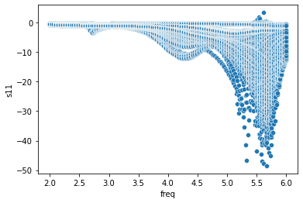

Fig. 3. Scatterplot representing the relationship between the Resonant frequency and the return loss

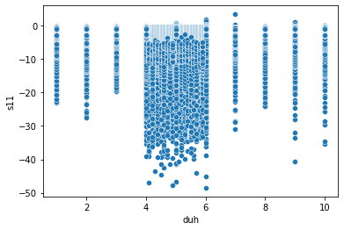

Fig. 4. Scatterplot representing the relationship between the Resonant frequency and the height of upper DRA

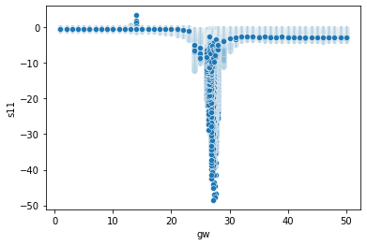

Fig. 5. Scatterplot representing the relationship between the Resonant frequency and the ground length

1. *Machine Learning Algorithm Implementation*

Predictive modeling involves the application of five distinct algorithms: decision tree, random forest, KNN, and ANN. These algorithms have been specifically chosen for their capability to perform regression on non-linear data, which is crucial given that the desired output is a numerical value.

Figure 6 illustrates the practical implementation of a machine-learning algorithm for predicting antenna dimensions. The dataset is initially read and then divided into an 80% training set and a 20% test set, adhering to recommendations in [17]. A machine learning approach, with various parameters, is subsequently employed to train the training set. Following the completion of the training phase, predictions are made using the test set. This methodological approach ensures a robust evaluation of the predictive capabilities of the machine learning algorithms in the context of antenna dimension forecasting.

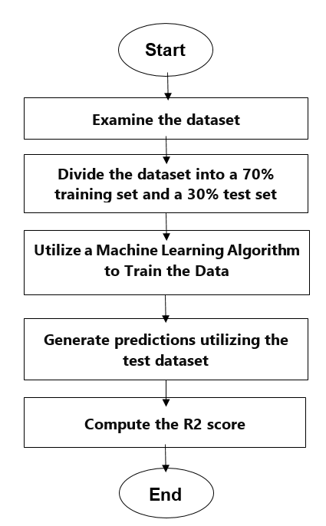

Fig. 6. Machine learning algorithm implementation flowchart

* + 1. *Decision Tree*

Decision Tree:

The decision tree serves as a supervised machine learning algorithm and functions as a predictive model for determining target values. It visually represents all possible decision options available, forming a graphical structure. This algorithm acquires fundamental decision rules and predicts the target value by traversing from the root node through the value-associated branch nodes and progressing to subsequent nodes until reaching the terminal node[18].

Random Forest:

Random forest, a member of the supervised machine learning algorithm family, comprises a forest of multiple decision trees[9]. This algorithm addresses potential overfitting issues encountered with individual decision trees. Typically, Random Forest employs the bagging method during training, emphasizing the notion that combining diverse learning models enhances overall results. By aggregating knowledge from various models and consolidating their contributions, the algorithm substantially improves predictive outcomes.[19]

Gradient Boosting Regression:

The gradient boosting algorithm operates both as a classifier and a regressor for predicting the target variable. When utilized as a regressor, the cost function employed is the mean square error (MSE). [20]The fixed base estimator for the gradient boost algorithm is the decision stump. The default value for the number of estimators in this method is 100, although it can be adjusted to achieve varying results.

K-Nearest Neighbor:

KNN 10] is a supervised machine learning technique proficient in both classification and regression tasks, leveraging the concept of k neighbors (instances) for decision-making.[21] By assessing the similarity between sample points, KNN predicts new data points based on their likeness to the existing training set data. This resemblance is quantified using a distance metric, such as the Euclidean distance.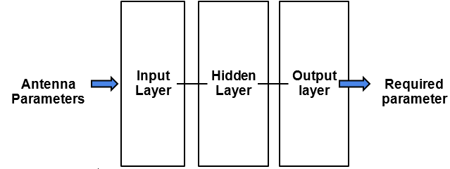

Fig. 7. Model Flow

* + 1. *Neural Network*

A Deep Neural Network is a type of ANN that has multiple layers between the input and output layers. The structure of the human brain influenced neural network algorithms.[22] Neural networks collect data and train themselves to identify patterns in it so that they can predict outputs for future sets of similar data.[23] The antenna geometry is then input into the neural network's multiple-layered architecture to create the model as shown in Fig. 7.

* + 1. *Loss Function*

The loss function represents the prediction inaccuracy in regression calculations. The smaller the loss function value, the more accurate the prediction. The prediction error can be calculated using a number of loss functions, including sum of errors (SE), sum of absolute error (SAE), SSE, MSE and so on [11]. MSE's advantage over other loss functions is that the overall error reduces as the data size increases. MSE averages the error into a single value, making it easy to determine whether the result obtained is good or not. The formula for determining MSE is shown in the equation below.

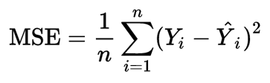

-(1)

1. *Parameters prediction using ML algorithms*

For predicting the best parameters using the ML algorithm, we have selected a range of values for our parameters. The height of the upper DRA is varied between 1 to 10 mm with a difference of 0.1 mm, which gives us 100 different values for this parameter. Similarly, ground length is varied for 1 to 50 mm with the same difference giving us 500 different values. Earlier we have the 200 values for frequency between 2 and 6 GHz. So, combining all values of these 3 parameters gives us a dataset of 10000000 rows and 3 columns.

After training the ML models with the dataset obtained from HFSS, we will select the best model with the highest R2 score and lowest MSE value. Then we will run this dataset of 10000000 rows and 3 columns on that model and will predict the S11 value for it. Then we will select those parameters which gave us the lowest S11 value. Those will be our best parameters.

1. Result and simulation

The application of Machine Learning Optimization in Circularly Polarized Antenna for 5G application has yielded insightful results through comprehensive simulations. The study aimed to assess the effectiveness of various machine learning algorithms in predicting antenna dimensions based on critical parameters such as resonant frequency and reflection coefficient.

1Dataset Generation and Simulation

The research involved the simulation of antennas using HFSS, exploring a range of dimensions with resonant frequencies spanning 2 to 6 GHz. The resulting dataset encapsulated key parameters, including resonance frequency, reflection coefficient, height of the upper dielectric resonator, and length to the ground.

2 Machine Learning Algorithms

Five machine learning algorithms were employed in this study: decision tree, random forest regression, gradient boosting regression, KNN, ANN. [24]These algorithms were chosen for their capacity to handle non-linear regression, aligning with the complex nature of the dataset derived from simulations.

3 Prediction Accuracy Evaluation

To assess the prediction accuracy of the machine learning models, the Mean Squared Error (MSE) value was calculated by comparing the simulated and predicted antenna parameters. This quantitative metric provides a robust evaluation of the efficacy of the machine learning algorithms in anticipating antenna dimensions.

4 Key Findings

The simulations yielded significant insights into the performance of machine learning optimization in circularly polarized antennas for 5G applications:

Algorithm Performance: Among the employed algorithms, the KNN algorithm with k=9 demonstrated the highest accuracy, achieving a remarkable accuracy rate of up to 98.7%. This finding underscores the efficacy of the chosen machine learning methodologies in predicting antenna dimensions.

Efficiency Gains: The integration of machine learning optimization showcased substantial efficiency gains compared to traditional trial and error methods. The streamlined process facilitated by machine learning algorithms presents a promising approach for expediting the antenna design optimization.

The antenna analysis has been done and shown in this section. Then MSE result and R2 score for each Machine Learning algorithm are shown in this section.

1. *Antenna Analysis and results*

The DRA antenna has been developed and tested on HFSS with a response in the sub-6 GHz range. The parametric study of important design parameters has been conducted. Fig. 8 Plots the antenna reflection coefficient taking different dimensions of the height of the upper DRA. A difference of h up to 5 mm changes the impedance bandwidth significantly, but there is no significant improvement in bandwidth over 5 mm. The height of the upper DRA is selected at 5 mm for the suitability of the design structure.

Another parametric analysis is performed by changing the length of the ground plane, as shown in Fig. 9. The fluctuations in the bandwidth curves are found by varying the length of the ground plane. It has been found that for 27.1 mm, the best-equipped bandwidth is obtained with a reflection coefficient value of -41 dB.

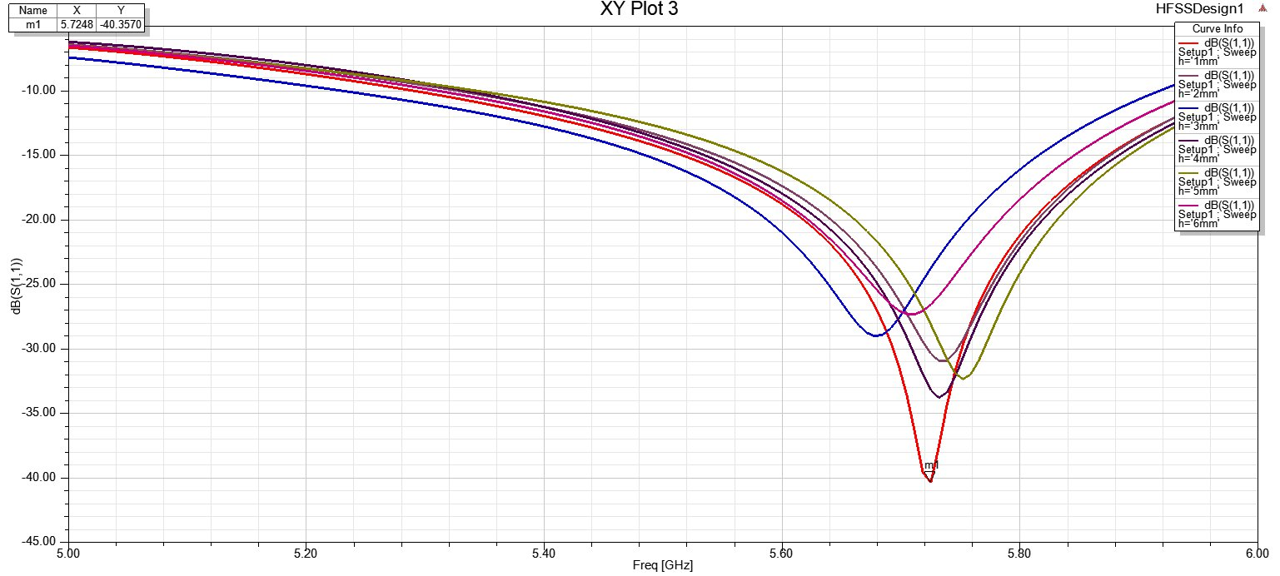

Fig. 8. Variation of return loss parameter with the height of upper DR

The antenna showed increased impedance at 5.75 GHz with a return loss value of -30dB. The behavior of the impedance bandwidth features with the partial plane was the key to the design. By varying the length and position of the ground plane, better impedance characteristics were achieved in the antenna configuration. In antenna gain, dipole-like behavior was also observed. The main feature of the architecture is the achieved circular polarization. The 3D plot of the proposed antenna's gain in the broadside region shows bidirectional radiation with a maximum gain of 4.36 dB.

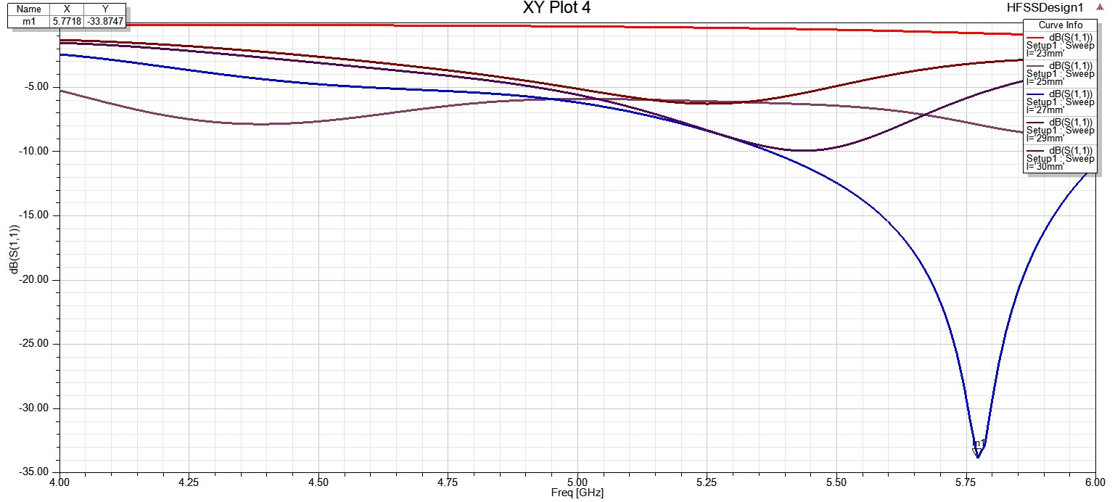

Fig. 9. Variation of return loss parameter with the length of the ground plane

The compact scale of the structure makes it more appropriate for usage in the lower microwave frequency band between 2-6 GHz. The antenna's ability to communicate across short distances allows for equipment mobility and fast transmission speeds, which makes information sharing easier and faster.

The antenna is simulated in HFSS, and the results determine that the studied antenna model is suitable for 5G applications.

1. *Machine learning model results and comparison*

Table I shows the prediction accuracy of the used ML algorithms through the R2 score and MSE value. The name of the ML algorithm used is written there in the first column of the table. The second and third column shows the R2 score and MSE values respectively of the respected ML techniques used. The R2 score is a popular metric for evaluating regression models. It indicates the accuracy of our regression model. It is the predicted amount of variation in the output dependent characteristic from the input independent variable (s). MSE is calculated by comparing the predicted and actual simulation results.

**TABLE I:** Different Model’s R2 Score and Mean Squared Error (MSE)

|  |  |  |  |
| --- | --- | --- | --- |
|  | **Model** | **R2 score** | **MSE** |
| 1 | Decision Tree | 0.964 | 0.701 |
| 2 | Random Forest | 0.978 | 0.422 |
| 3 | Gradient Boosting regression | 0.936 | 1.246 |
| 4 | K-Nearest Neighbor (n_neighbors=9) | 0.987 | 0.239 |
| 5 | Artificial Neural Network | 0.948 | 1.32 |

As shown from table I, KNN with n_neighbors=9 gives us the best prediction accuracy. Then we predicted the S11 values for our new dataset of 10000000 rows and 3 columns on this KNN model. It gave us the minimum value for S11 equals -34.75315746267342 where the upper DRA height is 5.0 mm and ground length is 27.6 at the frequency of 5.31 GHz.

V. IMPLICATIONS AND FUTURE DIRECTIONS

The successful application of Machine Learning Optimization in Circularly Polarized Antennas for 5G applications opens avenues for transformative implications and suggests compelling directions for future research.

1 Implications

1.1 Advancements in Antenna Design: The demonstrated efficacy of machine learning algorithms in predicting antenna dimensions signifies a significant advancement in the field of antenna design. This transformative approach can potentially redefine the traditional iterative design process, offering efficiency gains and paving the way for innovative antenna configurations.

1.2 Time and Resource Savings: The streamlined optimization process achieved through machine learning contributes to considerable time and resource savings. By mitigating the need for extensive trial and error iterations, this approach holds promise for accelerating the development of antennas tailored for 5G applications.

1.3 Enhanced Predictive Accuracy: The high accuracy rates, particularly with algorithms such as KNN, suggest that machine learning optimization can provide precise predictions for antenna parameters.[25] This has implications not only for circularly polarized antennas but also for other antenna configurations, extending the potential impact of this methodology.

2 Future Directions

2.1 Exploration of Additional Algorithms: Future research endeavors may involve exploring a broader array of machine learning algorithms to assess their suitability for antenna design optimization. Investigating the performance of emerging algorithms could enhance the robustness of the methodology and uncover novel insights.

2.2 Parameter Refinement: Refining the parameters included in the dataset can contribute to a more nuanced understanding of the relationships between different variables and further improve the accuracy of predictions. Continuous refinement of input parameters will be crucial for optimizing the machine learning models.

2.3 Application to Diverse Antenna Configurations: Expanding the scope of this methodology to encompass diverse antenna configurations beyond circularly polarized antennas would be a valuable avenue for future research. Understanding how machine learning optimization adapts to different geometries and frequencies could broaden its applicability.

2.4 Real-world Implementation and Validation: Transitioning from simulation to real-world implementation and validation is a critical next step. Assessing the performance of machine learning-optimized antennas in practical 5G scenarios will provide insights into the scalability and reliability of the proposed methodology.

The implications and future directions outlined above underscore the potential of Machine Learning Optimization to revolutionize antenna design for 5G applications. As this field continues to evolve, researchers have the opportunity to explore new algorithms, refine parameters, expand the scope of applications, and validate the real-world efficacy of this innovative approach.[26] These endeavors will contribute to the ongoing transformation of antenna design and optimization in the era of advanced communication technologies

VI. CONCLUSION

The exploration of Machine Learning Optimization in Circularly Polarized Antennas for 5G applications has revealed promising outcomes, paving the way for impactful advancements in antenna design and optimization.

Recapitulation of Findings

The comprehensive simulations and results presented in this study demonstrate the efficacy of machine learning algorithms in predicting antenna dimensions based on crucial parameters. Notably, the KNN algorithm with k=9 emerged as the most accurate, achieving a commendable accuracy rate of up to 98.7%. The streamlined optimization process facilitated by machine learning offers substantial efficiency gains compared to traditional trial and error methods.

Contributions to Antenna Design

This research contributes significantly to the field of antenna design, presenting a transformative approach to the optimization process. The ability to expedite design iterations, coupled with the precise predictions offered by machine learning algorithms, opens new possibilities for creating advanced circularly polarized antennas tailored for the demands of 5G applications.

Implications for Future Research

The implications and future directions discussed highlight the potential for further innovation in this domain. Exploring additional algorithms, refining parameters, applying the methodology to diverse antenna configurations, and transitioning to real-world implementations are crucial steps for the continued evolution of machine learning optimization in antenna design.

This research marks a significant step forward in harnessing machine learning for circularly polarized antenna optimization. The findings not only contribute to the academic understanding of antenna design but also offer tangible applications for creating advanced and efficient communication systems crucial for the evolving landscape of 5G technology. This study employs five distinct machine learning algorithms to predict optimal design parameters for Circular Polarized Dielectric Resonator Antennas suitable for 5G applications. The utilized machine learning models include Decision Tree, Random Forest, Gradient Boosting regression, KNN, and ANN. Following training on the dataset, these algorithms efficiently evaluate the performance of the reference antenna across over 10,00,000 design points in a matter of seconds. Notably, in comparison to other algorithms, KNN with k_neighbors=9 stands out, providing more accurate results with an MSE of 0.239 and an R2 score of 0.987.

In conclusion, the application of modern machine learning algorithms proves to be more efficient in achieving optimal antenna designs compared to traditional electromagnetic (EM) simulation optimization methods. The computational limitations of EM devices make optimizing complex antenna designs with numerous parameters challenging and time-intensive. The integration of machine learning techniques into simulation software addresses this challenge, offering a streamlined and effective approach. This study underscores the significance of machine learning-assisted antenna design methods in the realm of 5G wireless communication, providing a novel and efficient solution to intricate optimization challenges.

.

VII References

1. Massa, G. Oliveri, M. Salucci, N. Anselmi, and P. Rocca, “Learning-by-examples techniques as applied to electromagnetics,” J. Electromagn. Waves Appl., vol. 32, no. 4, pp. 516–541, Mar. 2018.
2. Plonis, Darius Katkevičius, Andrius Krukonis, Audrius Rusen, Vaiva

Maskeliunas, Rytis Damaševičius, Robertas. (2019). Predicting the Frequency Characteristics of Hybrid Meander Systems Using a FeedForward Backpropagation Network. Electronics. 8. 85.

10.3390/electronics8010085.

1. Z. Zheng, X. Chen, and K. Huang, “Application of support vector machines to the antenna design,” Int. J. RF Microw. Comput.-Aided Eng., vol. 21, no. 1, pp. 85–90, Jan. 2011.
2. T. Sallam, A. B. Abdel-Rahman, M. Alghoniemy, Z. Kawasaki, and T. Ushio, “A neural-network-based beamformer for phased array weather radar,” IEEE Trans. Geosci. Remote Sens., vol. 54, no. 9, pp. 5095–5104, Sep. 2016.
3. K.-C. Lee and T.-N. Lin, “Application of neural networks to analyses of nonlinearly loaded antenna arrays including mutual coupling effects,” IEEE Trans. Antennas Propag., vol. 53, no. 3, pp. 1126–1132, Mar. 2005.
4. Kaushik, P. (2023). Artificial Intelligence Accelerated Transformation in The Healthcare Industry. Amity Journal of Professional Practices, 3(01). <https://doi.org/10.55054/ajpp.v3i01.630>
5. Kaushik P. Role and Application of Artificial Intelligence in Business Analytics: A Critical Evaluation. International Journal for Global Academic & Scientific Research. 2022;1(3):01–11. https://doi.org/10.55938/ijgasr.v1i3.15
6. L. Zhang, Q. Ni, G. Zhang, M. Zhai, J. Moreno, and C. Briso, “Random forests-enabled context detections for long-term evolution network for railway,” IET Microwaves, Antennas Propag., vol. 13, no. 8, pp. 1080–1086, 2019.
7. S. B. Imandoust and M. Bolandraftar, “Application of k-nearest neighbor (kNN) approach for predicting economic events: Theoretical background,” Int. J. Eng. Res. Appl., vol. 3, no. 5, pp. 605–610, Sep./Oct. 2013.
8. Kaushik, P. (2023). Congestion Articulation Control Using Machine Learning Technique. Amity Journal of Professional Practices, 3(01). <https://doi.org/10.55054/ajpp.v3i01.631>
9. D. M. W. Powers, "Evaluation: From Precision, Recall and F-Measure to ROC, Informedness, Markedness & Correlation," Journal of Machine Learning Technologies, vol. 2, no. 1, pp. 37-63, 2011.
10. Kaushik P. Unleashing the Power of Multi-Agent Deep Learning: Cyber-Attack Detection in IoT. International Journal for Global Academic&Scientific Research. 2023;2(2):23–45. <https://doi.org/10.55938/ijgasr.v2i2.46>
11. Kaushik, P. (2024). Machine Learning Algorithms Aided Disease Diagnosis and Prediction of Grape Leaf. In: Udgata, S.K., Sethi, S., Gao, XZ. (eds) Intelligent Systems. ICMIB 2023. Lecture Notes in Networks and Systems, vol 728. Springer, Singapore. https://doi.org/10.1007/978-981-99-3932-9_2
12. Sharma T, Kaushik P. Leveraging Sentiment Analysis for Twitter Data to Uncover User Opinions and Emotions. International Journal on Recent and Innovation Trends in Computing and Communication. 2023;11(8s):162–169. https://doi.org/10.17762/ijritcc.v11i8s.7186
13. Sharma V. A Study on Data Scaling Methods for Machine Learning. International Journal for Global Academic & Scientific Research. 2022;1(1):23–33. https://doi.org/10.55938/ijgasr.v1i1.4
14. Yadav M, Kakkar M, Kaushik P. Harnessing Artificial Intelligence to Empower HR Processes and Drive Enhanced Efficiency in the Workplace to Boost Productivity. International Journal on Recent and Innovation Trends in Computing and Communication. 2023;11(8s):381–390. https://doi.org/10.17762/ijritcc.v11i8s.7218
15. M. Tan, B. Zheng, J. K. Leader, and D. Gur, “Association between changes in mammographic image features and risk for near-term breast cancer development,” IEEE Transactions on Medical Imaging, vol. 35,

no. 7, pp. 1719–1728, 2016.

1. Kaushik P, Rathore SPS. Deep Learning Multi-Agent Model for Phishing Cyber-attack Detection. International Journal on Recent and Innovation Trends in Computing and Communication. 2023;11(9s):680–686. https://doi.org/10.17762/ijritcc.v11i9s.7674
2. Kaushik P, Miglani S, Shandilya I, Singh A, Saini D, Singh A. HR Functions Productivity Boost by using AI. International Journal on Recent and Innovation Trends in Computing and Communication. 2023;11(8s):701–713. <https://doi.org/10.17762/ijritcc.v11i8s.7672>
3. Z. Yang, L. Ran, S. Zhang, Y. Xia, and Y. Zhang, “EMS-net: ensemble of Multiscale convolutional neural networks for classification of breast cancer histology images,” Neuro computing, vol. 366, pp. 46–53, 2019.
4. Kaushik P, Singh Rathore SPS, Kaur P, Kumar H, Tyagi N. Leveraging Multiscale Adaptive Object Detection and Contrastive Feature Learning for Customer Behavior Analysis in Retail Settings. International Journal on Recent and Innovation Trends in Computing and Communication. 2023;11(6s):326–343. <https://doi.org/10.17762/ijritcc.v11i6s.6938>
5. Pratap Singh Rathore S. The Impact of AI on Recruitment and Selection Processes: Analysing the role of AI in automating and enhancing recruitment and selection procedures. International Journal for Global Academic & Scientific Research. 2023;2(2):78-93. https://doi.org/10.55938/ijgasr.v2i2.50
6. Rathore R. A Study on Application of Stochastic Queuing Models for Control of Congestion and Crowding. International Journal for Global Academic & Scientific Research. 2022;1(1):01–07. https://doi.org/10.55938/ijgasr.v1i1.6
7. Pratap Singh Rathore S. The Impact of AI on

Recruitment and Selection Processes: Analysing

the role of AI in automating and enhancing recruitment and selection procedures.International Journal for Global Academic &Scientific Research. 2023;2(2):78-93.https://doi.org/10.55938/ijgasr.v2i2.50

1. Rathore R. A Review on Study of application of

queueing models in Hospital sector. International Journal for Global Academic &amp; Scientific Research. 2022;1(2):01–05.

https://doi.org/10.55938/ijgasr.v1i2.11